Python Default Arguments

When you call a function and pass an argument to the parameter that has a default value, the function will use that argument instead of the default value.

However, if you don’t pass the argument, the function will use the default value.

To use default parameters, you need to place parameters with the default values after other parameters. Otherwise, you’ll get a syntax error.

Example:

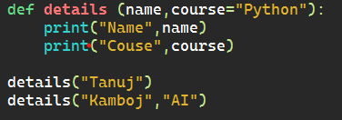

Output:

